2023

EasySave

Prosoft

14/02/2023

User Manual

Table of Contents

a) Installation 2

b) Location of the configuration file 2

c) Basic configuration 3

d) First launch 4

e) Choice of language 4

f) The Menu 5

g) "New" button 5

h) "Backup" button 6

i) "Parameter" button 6

## Installation

To be able to use the EasySave software, Prosoft will provide you with a .zip that you will have to extract on your pc. We advise you, once the .zip extracted, to put the folder "EasySave" on the following path: "C:\Users\nom_de_l user".

An image containing text

Auto-generated description

## Location of the configuration file

The configuration file is always located in the software folder "EasySave", under the name " EasySave.dll.config " with the following path:

An image containing text

Auto-generated description

In this file you will be able to configure the locations of the daily log file, containing the history of the backup job actions, the single file containing the progress of the backup jobs and the location of your project. (see "Basic configuration")

**Attention it is important to modify this configuration file so that it corresponds to your usage settings before the first use of EasySave.**

## Basic configuration

A minimum of configuration is necessary before the first launch of EasySave to ensure its proper functioning

Specify the locations of the daily log files (which contain the history of backup jobs ) and the location of the status log files for each backup job (which contain the progress of backup jobs).

Follow these instructions:

1-Open the "EasySave.dll.config" file with Notepad.

2- Its content will be as follows:

3-Copy the locations of the folders in which you want the different log files:

* StatusLogLocation = location of backup job status logs
* DailyLogLocation = location of daily log files
* LogFileName = the name of all log files
* MaxNumberOfSave = the maximum number of backup jobs SaveProjectLocation = the position of backup jobs
* LogsInXML: Logs to XML Y -> yes, N -> no
* LogInJson: Logs in Json Y -> yes, N -> no
* CryptosoftPath : Path to the Cryptosoft application (used to do encryption)
* CryptKey : Path to the 64 bit key used by Cryptosoft
* WorkProcessName : Name of the business software that prevent the launch of backups.

4- Then paste them instead of the default locations.

Warning: Make sure the locations are between the « ‘’ » characters!

## First launch

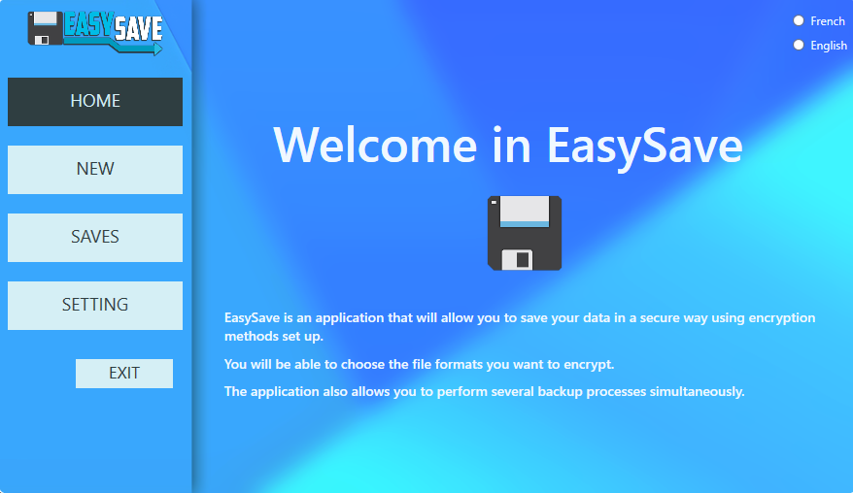The first time you launch the EasySave application, you will be directed to the home menu which briefly explains the usefulness of the application.

## Choice of language

The EasySave application is adapted in several languages including:

* French;
* English.

You will then be able to choose the language you want, by selecting it in the part at the top right of the application.

## The Menu

In the application, you have a menu on your left consisting of 5 buttons:

* Reception
* New
* Backups
* Parameter
* To leave

Each of these buttons will allow you to perform actions that we will explain one by one later.

## "New" button

When you click on the "NEW" button of the application, you will be able to create backup processes.

To do this you will have to enter the name of your backup, the path of the files to be backed up, the destination path of your backup. And finally you will have to select the type of backup according to:

- All files

- Only modified files

Then you will just need to click on the "Create" button to start creating the backup process.

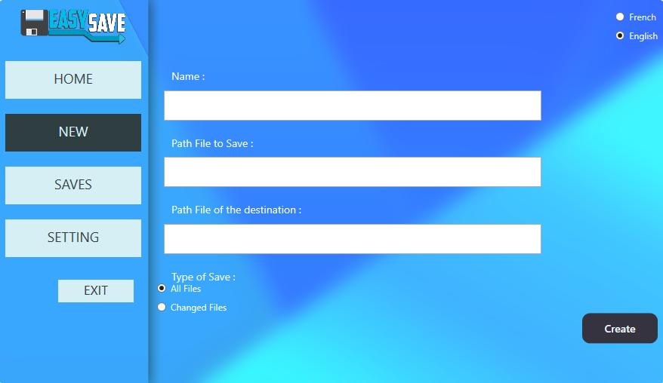

## "Backup" button

In the Backup part of the application, you will be able to view all the backup processes that you have previously created. You will also have the option to select one or more processes to start backups, with the "Launch" or "Launch all" button to start all backups.

You will also have the option to delete processes by selecting them and clicking on the "Remove" button.

Finally you can also refresh this page to display the latest processes using the "Refresh" button

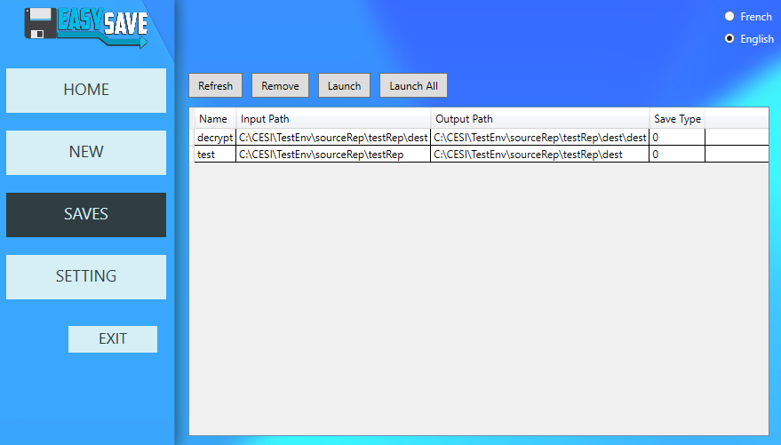

## "Parameter" button

Finally, the "Parameter" page will allow you to customize your backups by indicating the type of format for the logs, with several possible log formats:

* Json
* Xml
* Json et Xml

In addition, you will be able to select all the extensions of your files that will be encrypted when launching your backup processes.

And finally, you can also generate a 64-bit encryption key for Cryptosoft using the “Generate an encryption key” button.

